**1. Add the current date to the text file today.txt as a string.**

**Ans:** 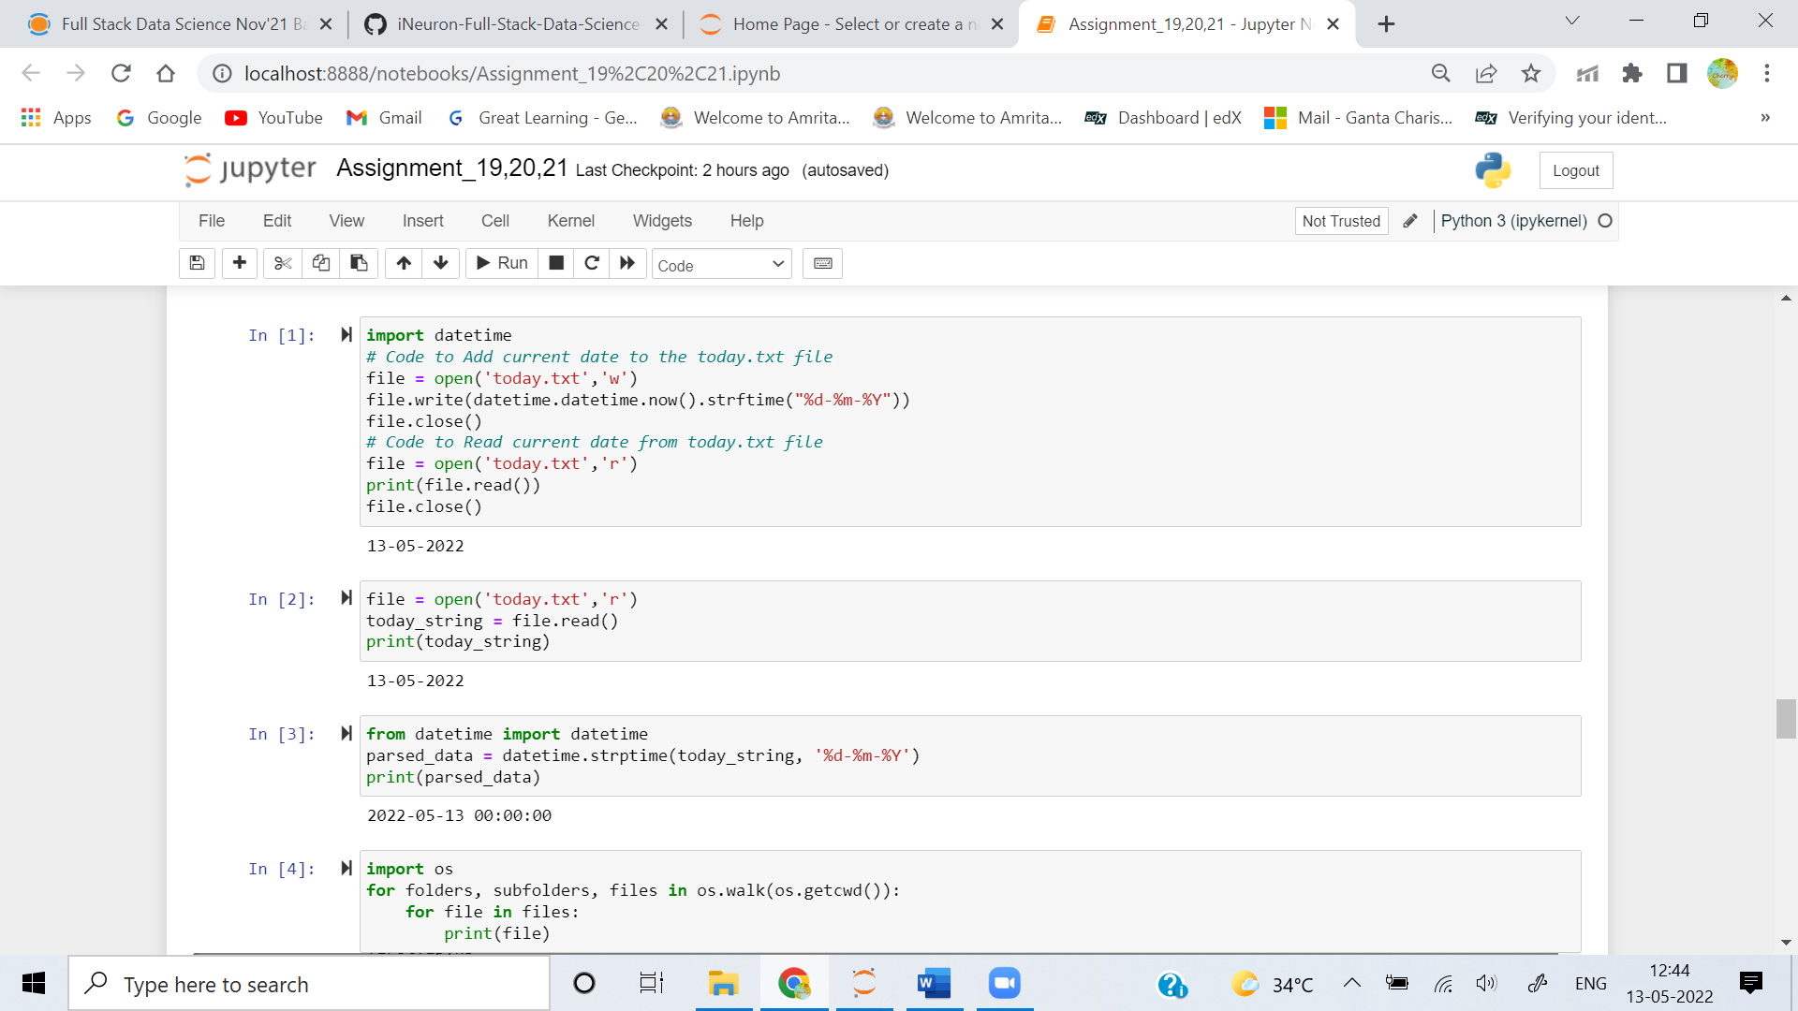

**2. Read the text file today.txt into the string today_string**

**Ans:** 

**3. Parse the date from today_string.**

**Ans:** 

**4. List the files in your current directory**

**Ans:** 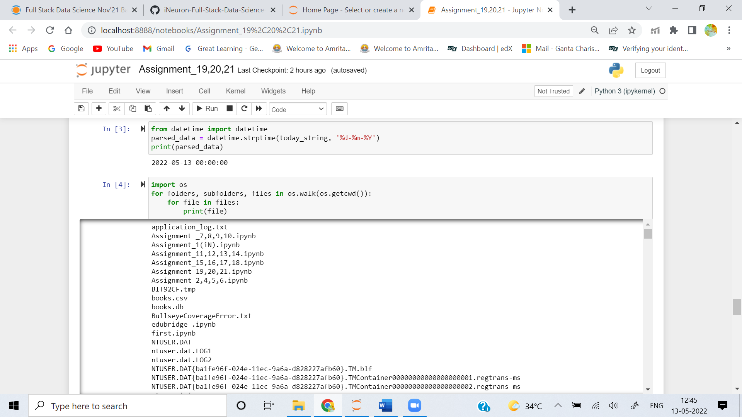

**5. Create a list of all of the files in your parent directory (minimum five files should be available).**

**Ans:** 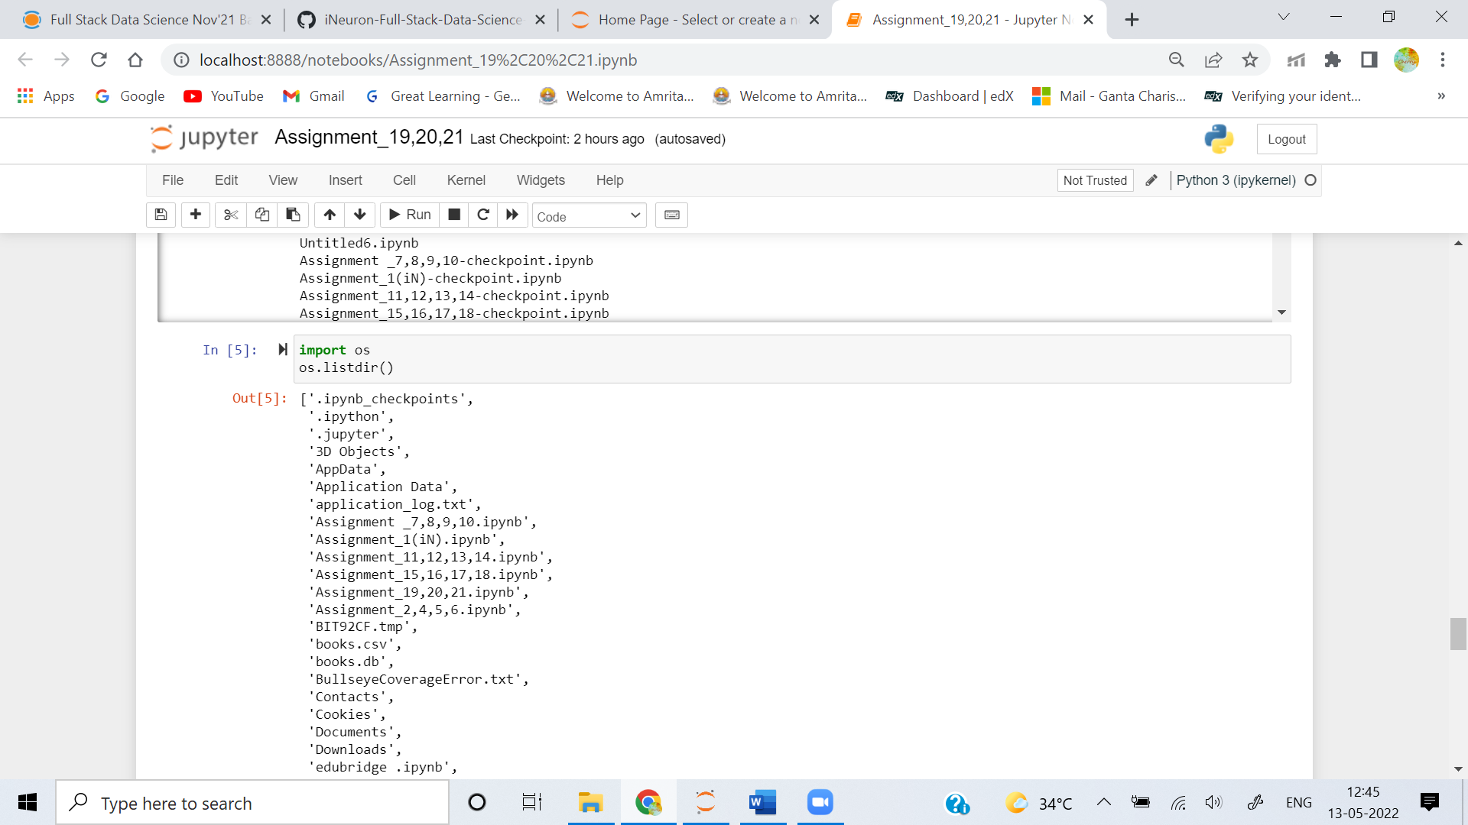

**6. Use multiprocessing to create three separate processes. Make each one wait a random number of seconds between one and five, print the current time, and then exit.**

**Ans:** 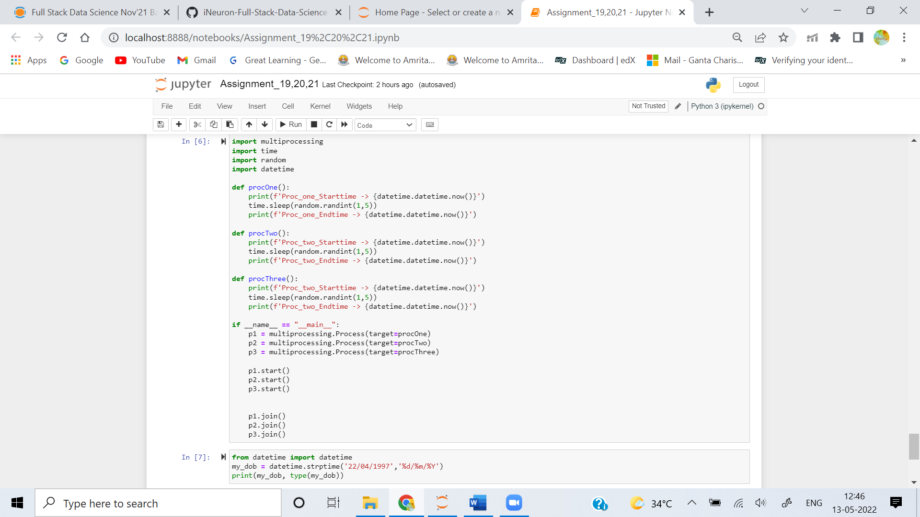

**7. Create a date object of your day of birth.**

**Ans:** 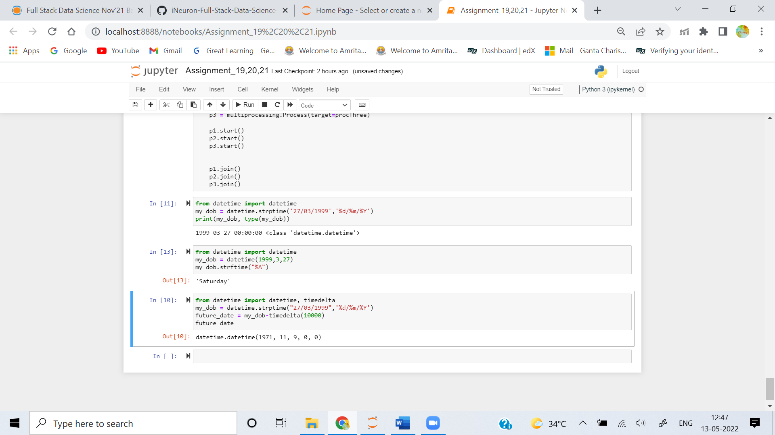

**8. What day of the week was your day of birth?**

**Ans:** 

**9. When will you be (or when were you) 10,000 days old?**

**Ans:** 